**Chasis**

Chasis is internal vehicle frame that provides base and supports an artificial object in its construction and use ,it also provides protection for some internal parts.

metal plates,fiber,or MDF materials can be used to make the chasis.

Metal plates are hard to work with. Cutting ,drilling, and welding requires special tools & too much efforts.

But MDF can be cut using normal hack-saw blade , and drilling can also be done easily.

So we used MDF material (Medium Density Fibreboard) to make the chasis.

Medium-density fibreboard (MDF) is a wood product made by breaking down hardwood or softwood residuals into wood fibres, often in a defibrator, combining it with wax and a resin binder, and forming panels by applying high temperature and pressure. MDF is generally denser than plywood.

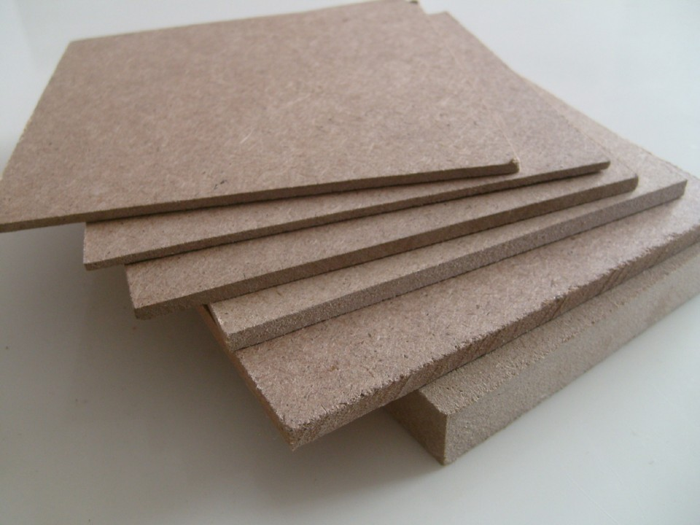

MDF is typically made up of 82% [wood fibre](https://en.wikipedia.org/wiki/Wood_fibre), 9% [urea-formaldehyde](https://en.wikipedia.org/wiki/Urea-formaldehyde) resin glue, 8% water and 1% [paraffin wax](https://en.wikipedia.org/wiki/Paraffin_wax).

### 

We chosen this material because of advantages like light weight and ease of use.

Screws

We used M3 mounting screws to assemble the chasis . we made 3 compartments for battery pack,controller and motor driver,

Reference

MDF <https://en.wikipedia.org/wiki/Medium-density_fibreboard>